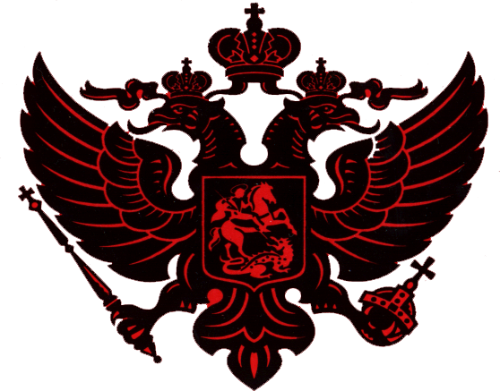
Blessing Of Nobility

In witness, to those who have gathered for the purpose of welcoming Neal Robert Holtzer into the Schultz Clan, I, Robert Irving Schultz, have deliberated and decided on the basis of the direct lineage of Neal Robert Holtzer to Genry Schulz, father of Jospeh Schulz (1649), and to Paul Trofimovich Sugakoff (1721), bestow upon Neal Robert Holtzer the status of nobility on May 28, 2002.

In witness whereof, we, Robert Irving Schultz, members of the clan, and those assembled here today in the presence of God must bear true witness to these events. I, with my signature, duly witnessed and validated, bestow upon Neal Robert Holtzer all the rights and duties belonging to him. Neal Robert Holtzer is henceforth to be known as a “dvoryanin,” which means a nobleman.

Robert Irving Schultz

Jeffry David Holtzer

