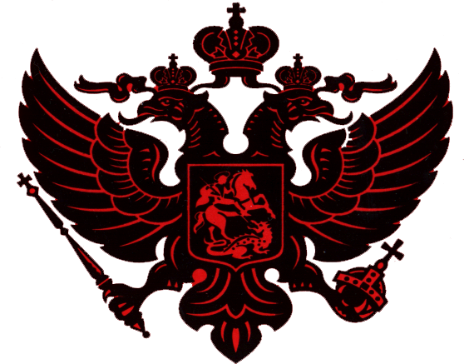 Schultz Family History
Alyssa Mackenzie Schultz
presented by: Robert Irving Schultz

My name is Robert Irving Schultz. I am Alyssa Mackenzie Schultz's Grandfather. I am here today to explain to you the Russian Heritage of my Clan. And, to officially welcome Alyssa Mackenzie Schultz into the Clan. The things that I will tell you today were told to me by my father Nicholas Pershing Schultz.

The Russia, The Russ, has a history that dates back 1,200 years. The period of the Kievan Russ lasted over 400 years. This was the period of the Great Kings and "The House of Rurik". The first capitol of the Russ was Kiev, and the surrounding kingdom was ruled by King Vladimir, 978-1015. Grand Prince Vladimir was christened and adopted Orthodox Christianity.

The second capitol of the Russ was the city of Suzdal. In 1238, the first battle with the Tatar's Mongols took place. The Mongols won the day and until 1480, The Russ paid tribute to the Mongols. After the Mongol invasions, the capitol was shifted to Moscow and the patriarch of the Russian Orthodox Church took up residence in Moscow. This is the Cathedral of Saint Basil.

In 1325-1380, the King of Moscow, Ivan-Kalita , Ivan Money Bags, and his followers unified the Russian States. His grandson Dmitri fought the Mongols in a battle at Kulikovo, meaning little bird, and was the victor. The battle lasted two days.

In 1480, Ivan III, finally defeated the Mongols and became the first Czar of the Russian Imperium, reign 1462--1505.

Mikhail Feodorovich was the founder of the royal dynasty of Romanovs. He ascended to the throne at the age of 16 and was crowned Czar on July 11, 1613, reign 1613--1645.

Genry Schulz, father of Josef Schulz, born 1649, was the first member of the Clan to serve in Russia. We do not know his story.

The Decree of Nobility granted by the Czar's to individuals is not to be taken lightly. It is only bestowed upon those individuals who through military or maritime deed or through statesmanship exhibit the principles of duty, honour, and decency.

The Certificate of Nobility granted April 21, 1785 by Catherine the Great of Russia to Paul Trofimovich Sugakof was duly registered in volume 4 of the Family Register of Nobility in the Kiev Province in 1795. The Certificate of the Kiev Province, "The Decree of Nobility, was brought to the United States by my great grandmother Marfa Dmitrievna Sugak Schulz, 1865-1955, Alyssa Mackenzie Schultz's great great great grandmother.

Albert Frederick Yulianovich Schulz, 1856-1917, Alyssa Mackenzie Schultz's great great great grandfather, moved the family from Kiev, Russia to the United States in 1892. He was a military officer with the Russian White Army, the armies of Czar Alexander II, reign 1855 – 1881, and Czar Alexander III, reign 1881 -- 1894. Upon returning to Russia in 1905 he served under his Imperial Majesty, Czar Nicholas II, reign 1894 -- 1917.

My grandfather Nikolai Albert Yulianovich Schulz, 1885-1961, Alyssa Mackenzie Schultz's great great grandfather, served under General John Joseph Pershing at the WW I battles of Chateau Thierry and Belleawood. He was wounded and awarded, with distinction the purple heart.

My father Nicholas Pershing Schultz, 1917-2000, Alyssa Mackenzie Schultz's great grandfather, was a Captain in the US Army Air Force during WWII. He served under General Henry Harley Hap Arnold.

I, Robert Irving Schultz, Alyssa Mackenzie Schultz's Grandfather, served with the US Army in Germany at the start of the Berlin Wall Crisis. I served under John Fitzgerald Kennedy, 35th President of the United States of America. My father bestowed the title upon me, Robert Irving Schultz.

I bear witness to you today that Alyssa Mackenzie Schultz is a direct decedent of Albert Frederick Yulianovich Schulz and Marfa Dmitrievna Sugak Schulz. Through my great grandfather Albert, Alyssa Mackenzie Schultz is a direct descendent of Genry Schulz, fourteenth generation. Through my great grandmother Marfa, she is a descendent of Paul Trofimovich Sugakof, who on April 21, 1785, was granted the Decree of Nobility by her Imperial Majesty, Catherine the Great of Russia.

I, Robert Irving Schultz, bestow upon Alyssa Mackenzie Schultz the Russian title, Dvoryanka, meaning a noblewoman.I hereby give to Alyssa Mackenzie Schultz the rights and privileges of her birth. From this day forward, Alyssa Mackenzie Schultz is to be known as the Lady Alyssa.

