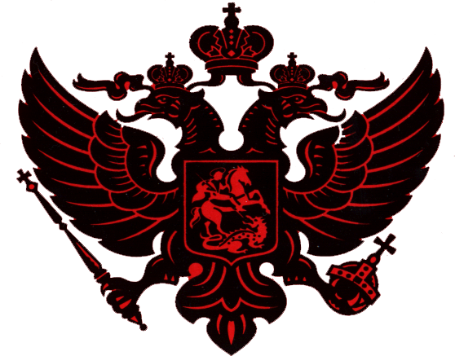
Blessing Of Nobility

In witness, to those who have gathered for the purpose of the christening of Kira Ann Holtzer, I Nicholas Pershing Schultz, have deliberated and decided on the basis of the direct lineage of Kira Ann Holtzer to Paul Trofimovich Sugakoff, bestow upon Kira Ann Holtzer the status of nobility on April 25, 1999.

In witness whereof, we, Nicholas Pershing Schultz, members of the clan, and those assembled here today in the presence of God must bear true witness to these events. I, with my signature, duly witnessed and validated, issue to Kira Ann Holtzer this Blessing of Nobility.

Nicholas Pershing Schultz

Jeffry David Holtzer

